08 October 2024

Natalia Palej

Student ID: A00279259

Software Design with AI for Cloud Computing

SQL Assessment

Q1

select count(distinct category_id) as “CategoryCount” from products;

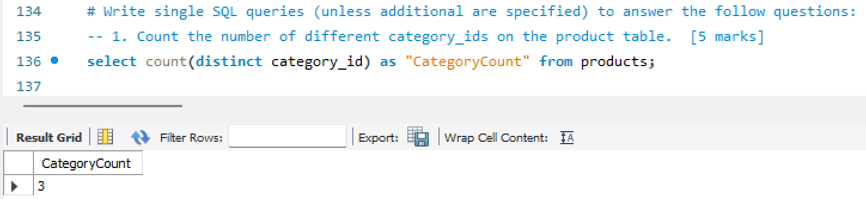

Q2

select first_name, last_name from customers where length(last_name) >= 6;

Q3

show databases;

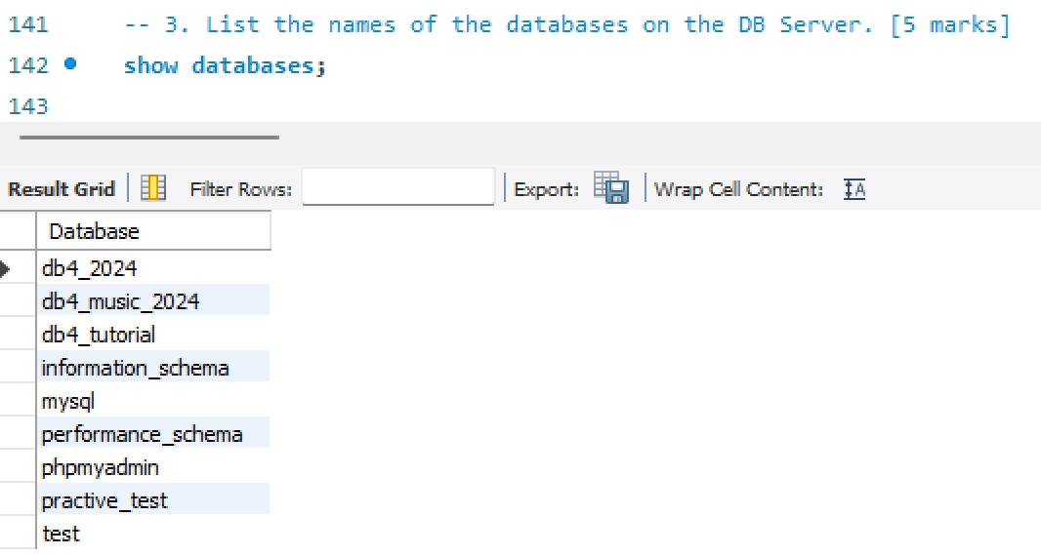

Q4

select sum(list_price) as "Total List Price", avg(list_price) as "Average List Price", avg(discount_percent) as "Average Discount Percent", max(list_price) as "H", min(list_price) as "L" from products;

Q5

select product_code, product_name from products where description like "%Cymbals%";

Q6

select first_name, last_name, email_address from customers where first_name like "__a%";

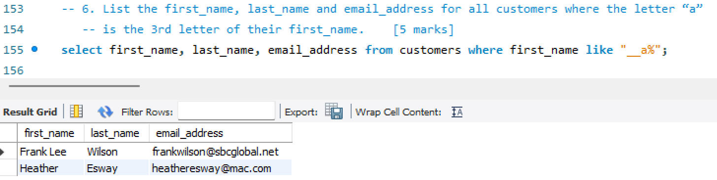

Q7

select product_code, product_name, list_price from products where list_price between 500 and 2000 group by product_code order by list_price asc;

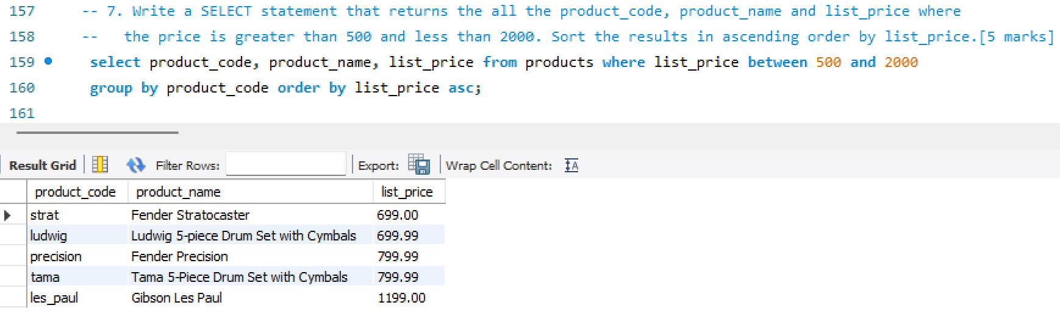

Q8

select c.category_name, p.product_name, p.list_price from products p join categories c order by c.category_name desc, p.product_name asc;

Q9

drop view if exists vwPriceAndDiscount;

create view vwPriceAndDiscount as select product_name as “Product”, list_price as "Price", discount_percent as "Discount", round((list_price*discount_percent)/100, 2) as "Discount Amount", list_price-round((list_price*discount_percent)/100, 2) as "Discounted Price" from products;

select * from vwPriceAndDiscount order by Product desc;

Q10

select product_name as "Product", sum(list_price) as "TotalPrice", sum(round((list_price*discount_percent)/100, 2)) as "TotalDiscount" from products group by product_name order by product_name desc;

Q11

select c.email_address, count(o.order_id) as "TotalOrders" from customers c left join orders o on c.customer_id=o.customer_id group by c.customer_id;

Q12

insert into categories (category_name) values ("Kazoos");

**NOTE: I have added originally as “Kazooos” and then noticed its supposed to be “Kazoos”, that’s why theres two entries 😊**

describe categories;

Q13

select * from categories;  
update categories set category_name="Misc" where category_name like "Kazoos";

Q14

drop procedure if exists sp_UpdateDiscountPercent;

delimiter //

create procedure sp_UpdateDiscountPercent(

productID int

)

begin

start transaction;

update products set discount_percent="99" where product_id=ProductID;

commit;

end //   
delimiter ;

select * from products where product_id=1;

call sp_UpdateDiscountPercent(1);

select * from products where product_id=1;

**Before calling** sp_UpdateDiscountPercent

**After calling** sp_UpdateDiscountPercent

Q15

drop function if exists fnGetDiscountedPrice;

delimiter //

create function fnGetDiscountedPrice(

productID int

)

returns decimal (9, 2)

begin

declare DiscountedPrice decimal(9,2);

select (list_price*discount_percent)/100 into DiscountedPrice from products where product_id=ProductID;

return DiscountedPrice;

end //

delimiter ;

select fnGetDiscountedPrice(1);

